Team Norwegian Forest Cat – Wind Turbine

# Summary:

We have made an electronic wind turbine that powers a house. The wind turbine was 3D printed and made of four parts: the base, the tower, the sail, and the blades. The house is made of cardboard with paper in the windows. The stand for the buttons was also 3D printed and includes six buttons with different functions.

# Method:

First, we made a plan for the wind turbine and the house that would be connected to it, then we used the computers to research and buy the parts we would need. Next, we used a 3D printer to make the separate parts of the model and used epoxy glue and screws to secure it. The button holder we designed was also 3D printed (with labels for each button), the buttons were secured with nuts and the wires were fixed on with glue. We also made the house out of cardboard boxes and stuck them together with tape. The windows were covered with plain paper so that the light could shine through, but the interior of the house was not visible. We had also added in the necessary parts such as light strips and a motor to make the wind turbine turn. We used Scratch to code the Raspberry Pi and additional MicroBit and used a wiring diagram we had created to wire all the parts together. Finally, we plugged everything into the Raspberry Pi and tested it to make sure it worked.

# What we learned:

We learned about different types of computer parts to build and power our wind turbine. We were taught how to connect a Raspberry Pi to a computer and which computers we could connect it to. We learnt how to use epoxy to glue the different parts of the wind turbine together, and we also now know how to tell apart male and female wires. Finally, we developed our knowledge of Scratch coding and which functions to use to code the movement and sound.

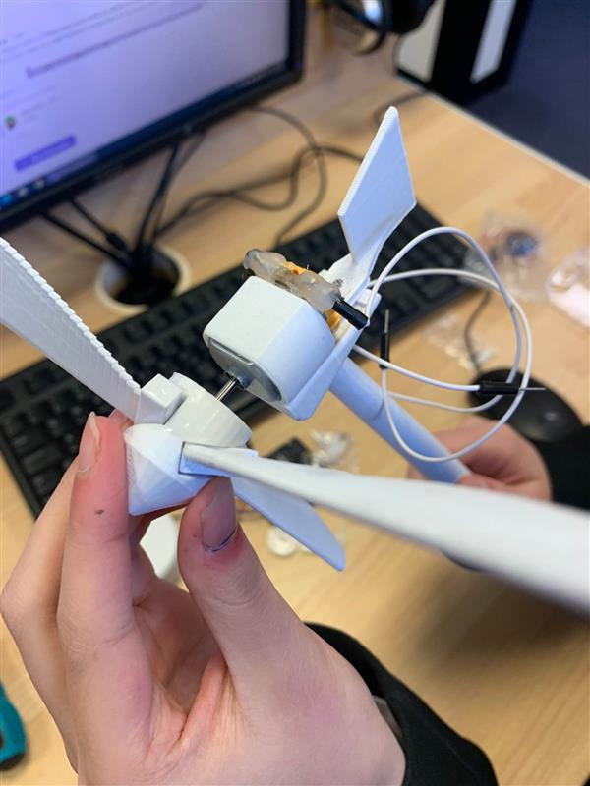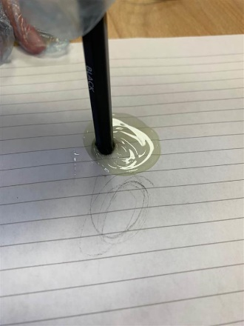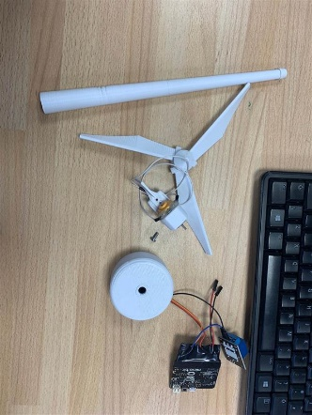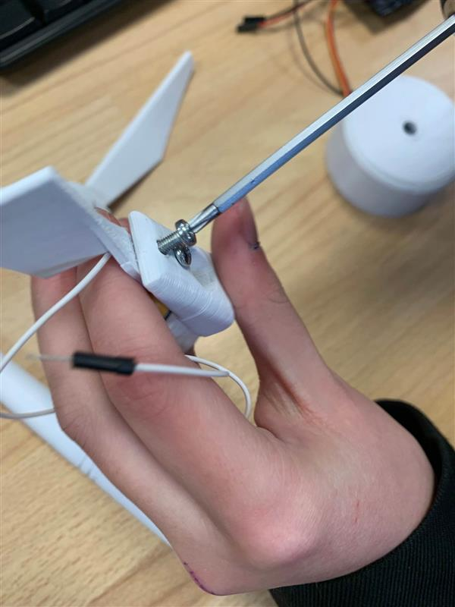

Equipment:

We bought the equipment from many different sites. We made a list of what we needed to purchase and found it on Amazon. There were lots of different products, so we compared the prices and bought the best value one. The things we bought included 3D printing filament, motors, a microBit, a USB sound card and a set of light strips.